# Step 1) Preparation

Download the zipped file, **w2-exercises.zip** , from the Blackboard

(**Content** 🡪 **Week 02 Dimensional Modeling…** 🡪 **Class Exercise** 🡪 **Week 02 Class Exercise Files**).

Extract the files into a folder.

Open the script **00-w2-sample-tables.sql** in a text editor and copy the DDL scripts starting from the line #278 to the end and paste them into your MySQL client (SQLYog, MySQL Workbench, Sequel Pro, etc) and execute them. Make sure that those three tables have been created in the **target_db** database.

Launch the PDI and open the transformation **09-category-lookup-with-surrogate.ktr** (**File** 🡪 **Open…**).

Save the transformation as (**File** 🡪 **Save As…**) **09-category-lookup-with-surrogate-YourID.ktr** (e.g. 09-category-lookup-with-surrogate-**dlee52**.ktr) .

Change database connections, the **Source DB** and the **Target DB** (see the screenshot below), to use your MySQL account information. For that, right click on each connection and click **Edit**. You may also want to set the connections to be shared (right click 🡪 **Share**) so to use them in another transformation.

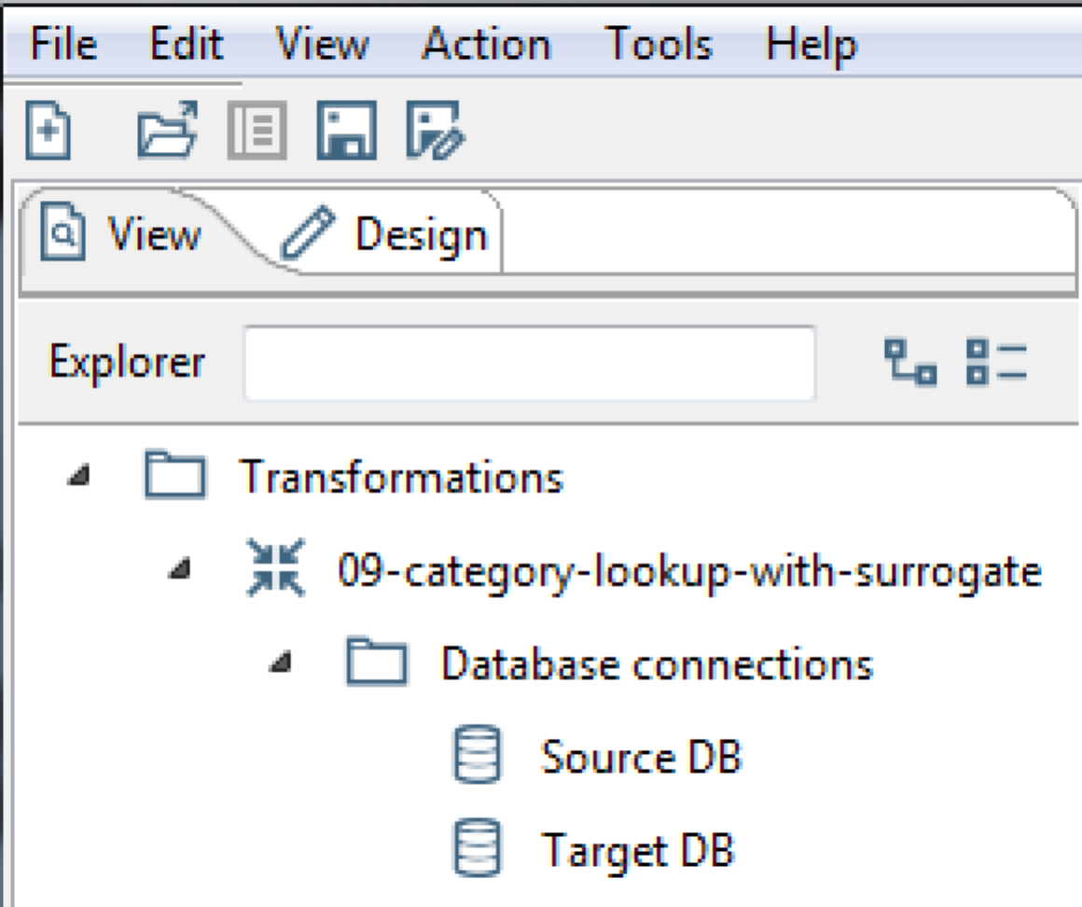

Save the transformation (**File** 🡪 **Save**).

Open the transformation **10-normalize-product-catalog.ktr** and save it as “**10-normalize-product-catalog-YourID.ktr**” (e.g. 10-normalize-product-catalog-**dlee52**.ktr).

# Step 2) Modify the 09-category-lookup-with-surrogate-YourID.ktr

Modify the new transformation, **09-category-lookup-with-surrogate-YourID.ktr**, to use the **outdoor_product_catalog_v2.xls** as the source input. This new source input has an additional column **prod_code**. However, the transformation will still produce the same result as the original transformation.

# Step 3) Modify the 10-normalize-product-catalog -YourID.ktr

Modify the new transformation, **10-normalize-product-catalog -YourID.ktr**, to use the **outdoor_product_catalog_v2.xls** as the source input and to the **product_v2** table as the target output. This new transformation must use the **prod_code** column as the natural key as opposed to the **prod_desc** column in the old transformation.

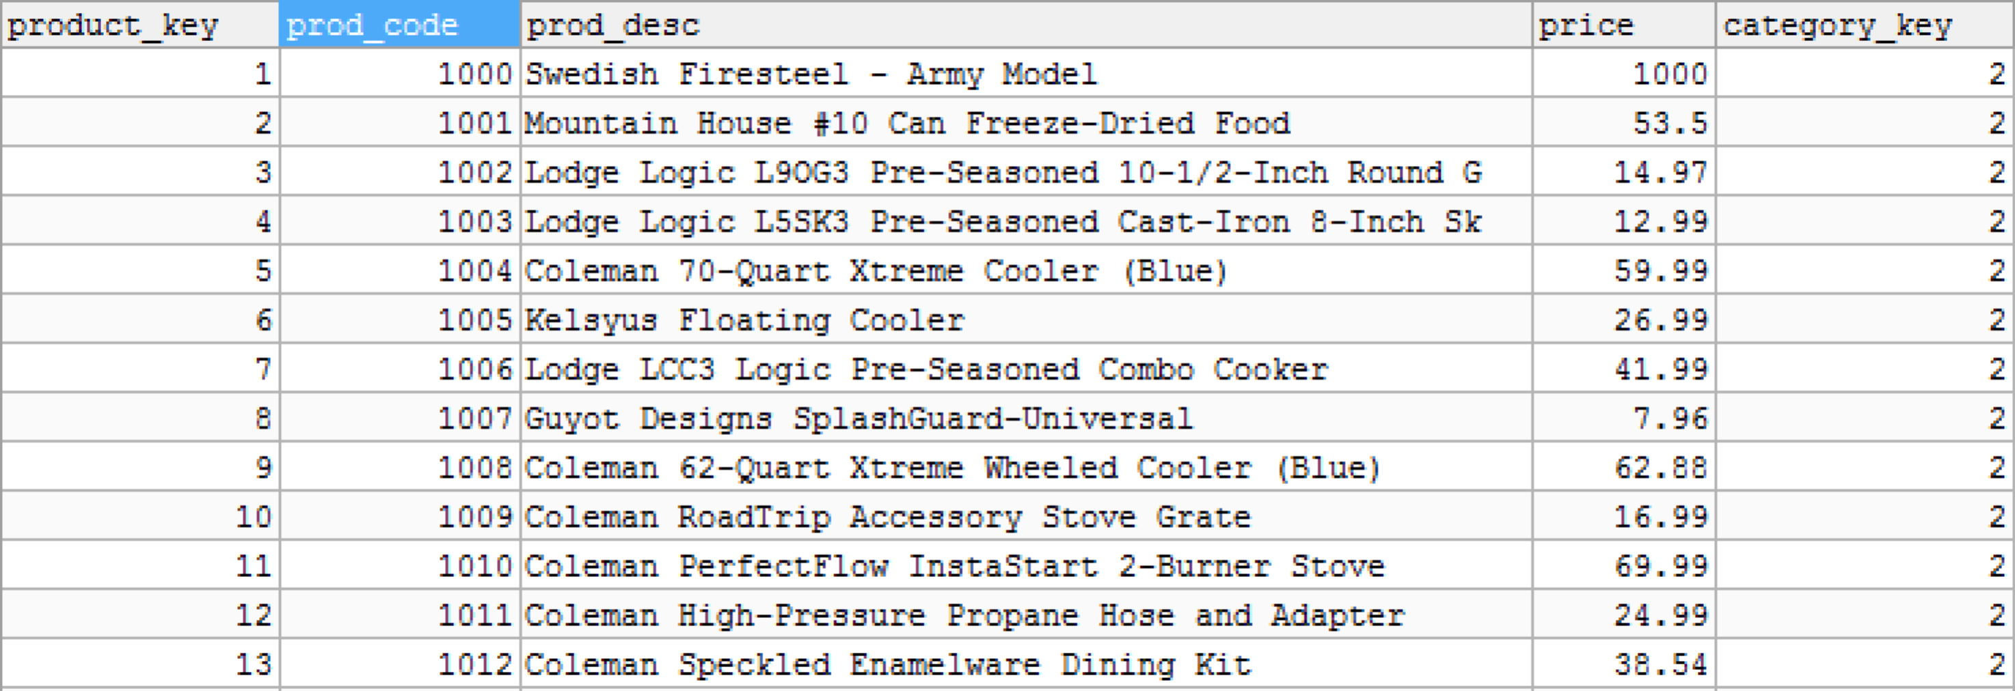

# Step 4) Confirm that any changes in the source input file (outdoor_product_catalog_v2.xls) get reflected into the output tables and submit the results to BB

Make some changes to the source input file, **outdoor_product_catalog_v2.xls**, and then run the two transformations to see if the changes you made are reflected into the output tables correctly.

*Submit the two transformations and the screenshots of your execution results in a single zipped file. The zipped file must follow the naming convention below:*

*yourID_week02.zip*

*(e.g. dlee02_week02.zip)*